**CHAPTER- 1**

**INTRUDUCTION**

The growth of online banking and digital transaction application has brought convenience and accessibility to millions of users worldwide. This generation revolution, however, has also given rise to new forms of cybercrime, particularly financial fraud. Online bank transaction fraud involves unauthorized activities such as identity theft, phishing, and money laundering, leading to substantial financial losses and erosion of customer trust. As the Occurrence and sophistication of fraudulent transactions continue to grow, Intelligent systems that can identify is desperately needed. and prevent fraud in real-time. Old- generation fraud detection systems are strongly based on rule-based mechanisms and historical data. While effective To a certain degree, such methods are unable to adapt to new, unseen fraud patterns and struggle with the **imbalance problem** — where there are considerably more legitimate transactions than fraudulent ones. Due to this mismatch, the majority of machine learning models may become biased toward forecasting the majority class and miss important but infrequent fraudulent transactions.

To address this, we propose a hybrid model that combines the power utilizing Generative Adversarial Networks with **SLT** such as **SVM**, **KNN**, and **LR**. The GAN is used to generate synthetic samples of fraudulent transactions, balancing the dataset and enriching the learning process of the classifiers. Once the data is balanced, the classifiers are trained to distinguish between legitimate and fraudulent transactions with improved accuracy. This integrated framework not only enhances fraud detection capabilities but also reduces false negatives and false positives, leading to a more secure and trustworthy online banking system. The proposed approach can be seamlessly integrated into existing financial systems to aid banks and financial institutions in safeguarding their operations against fraudulent activities.

# PURPOSE

The goal of this app is to design an intelligent and efficient fraud detection framework capable of identifying fraudulent online banking transactions in original time. To address the common challenge of highly imbalanced financial datasets, the system integrates **GANs** for sys data obtain with traditional ml models such as **SVM, KNN, LR**. This app present not only balances the dataset but also strengthens the accuracy, reliability, and robustness of fraud detection, ultimately ensuring secure and trustworthy digital banking operations.

# 1.2AIM

The project aims to create a hybrid false identification model for live banking by integrating GANs with conventional classifiers. Using synthetic fraudulent data, the system enhances the precision of separating legitimate transactions from fraudulent activities.

# 1.3PROBLEM STATEMENT

Online banking platforms face significant risks from fraudulent transactions, yet detecting them remains challenging due to the severe imbalance between legitimate and fraudulent records. Since fraudulent cases are rare, conventional ml models often struggle, leading to poor detection accuracy and a higher likelihood of false negatives. Therefore, there is an quick need for an intelligent fraud detection framework capable of learning from scarce fraudulent data, improving accuracy, and reducing false alarms to ensure secure digital financial services.

# 1.4OBJECTIVES

Generative Adversarial Network (GAN) to generate synthetic fraudulent transaction samples to address data imbalance. To practice and evaluateML classifiers such as SVM, KNN, and Logistic Regression on both original and GAN-augmented data. To compare the calculate of each divider using metrics.To build be adapted and integrated into real-world online banking applications for enhanced security



# EXISTING SYSTEM

Most existing fraud identification application rely on **rule-based algorithms**, **manual auditing**, or **native ML** such as Decision Trees, Naive Bayes, and Random Forests. These systems typically analyze historical transaction data and predefined patterns to flag suspicious behavior. Some systems use statistical techniques and supervised learning approaches trained on labeled datasets. to misclassify genuine transactions as fraudulent (false positives) or miss actual frauds (false negatives). Furthermore, they lack adaptability to emerging and evolving fraud pattern.

# 1.6PROPOSED SYSTEM

The proposed system introduces a **latest** by leveraging **GAN** to points the class imbalance problem and enhance the calculation of **SVM, KNN, and Logistic Regression classifiers**. The GAN model generates realistic synthetic fraudulent transactions.

**CHAPTER– 2**

**LITERATURE SURVEY**

Literature survey is a methodology of identifying the problems in the existing system through research and proposing of the system to solve the problems of existing system.

Swathi N et. al. explores [1] how old false identification app, which rely on static rules, are often ineffective against modern, evolving fraud patterns. It highlights how machine learning (ML) can adapt to new fraud tactics by learning from data, enabling proactive detection in online banking environments. Dataset Used: Real-time bank transaction data. To develop a real-time fraud detection system using ML algorithms like SVM, LR, and Neural Networks that continuously learn from streaming transaction data to provide immediate fraud alerts and reduce false positives.

Due to the rarity of fraudulent transactions, Meena R et. al. [2] in their ML models, often struggle with class imbalance. This paper proposes the use of GANs to synthetically create fraudulent samples that mimic real fraud cases, thereby enriching the dataset for improved model training.Dataset Used**:** Private banking transaction data Main Goal:To use GANs for fraudulent data and build an anomaly detection model capable of identifying hidden fraud patterns in highly imbalanced banking datasets with improved sensitivity and generalization.

Suman R et. al. [3] Mobile banking is increasingly targeted by fraudsters. This paper focuses on capturing behavioral anomalies using Convolutional Neural Networks (CNN) to classify user actions as normal or suspicious, with GANs used to enhance training with synthetic attack scenarios.Dataset Used: Mobile banking logsMain Goal:To simulate mobile fraud behaviors using GANs and classify them effectively using CNNs, enabling more accurate detection of irregular user activities such as sudden location changes, device switching, or unusual login times.

Rajesh T, Priya G et. al. [4] In fast-paced online payment ecosystems, detecting fraud in real-time is essential to financial loss. This paper highlights the significance of rapid processing and decision- making using tree-based algorithms.Dataset Used: Live transaction data from online payment systems. Main Goal:To design a fraud detection model using XGBoost and Decision Trees that can process transaction data instantly and generate fraud alerts within milliseconds, helping financial institutions stop fraudulent transactions before completion.

Ananya M, Sanjay R [5] The imbalance between genuine and fraudulent credit card transactions hinders the accuracy of ML models. This paper presents a Conditional GAN (CGAN) approach that generates fraudulent examples conditioned on transaction characteristics.Dataset Used: Kaggle credit card fraud dataset. Main Goal:To use CGANs for generating high-quality, realistic fraudulent transactions and balance the dataset, thereby enhancing the training process of SVM classifiers for accurate and robust credit card fraud detection.

Shweta R, Deepak K et. al. [6] This topic details how proper learning models, such as Long Short- Term Memory (LSTM) and Deep Neural Networks (DNN), can analyze sequential transaction data to uncover subtle, time-based fraud patterns that traditional ML may miss.Dataset Used: Private banking transaction logs. Main Goal:To build a deep learning-based system that uses LSTM to capture temporal patterns and DNNs for high-level feature extraction, with SHAP values employed for explainability to make the system transparent and interpretable.

Sneha S et. al. [7] Instead of analyzing transaction values alone, this paper focuses on user behavior analytics—such as login time, IP address, and device fingerprint—to detect anomalies. GANs are used to simulate genuine behavior patterns for anomaly detection training.Dataset Used: Bank user behavior and login data. Main Goal:To generate a baseline of normal user behaviors using GAN and detect deviations using anomaly detection algorithms, resulting in the identification of frauds even when financial values appear legitimate.

Abhinav J, Neha B et. al [8] Combining the data balancing strength of GANs with the classification ability of traditional ML creates a powerful hybrid system. This paper demonstrates how such a combination enhances fraud detection in online banking systems.Dataset Used: Public bank transaction dataset. Main Goal:To develop a hybrid framework where GANs synthesize fraud examples and ML models such as Random Forest and SVM classify transactions, improving accuracy and reducing missed fraud cases.

Naveen T, Haritha R et. al. [9] When labeled data is unavailable, unsupervised learning becomes essential. This paper introduces autoencoders as an effective approach to detect unusual transaction patterns without relying on predefined fraud labels.Dataset Used: Bank transaction logs Main Goal:To train deep autoencoders on normal transactions and identify frauds based on high reconstruction errors, allowing for effective fraud detection in scenarios where fraud labels are scarce or unknown.

Preethi L et. al. [10] Different types of fraud require different detection mechanisms. This paper uses multiple GAN models, each specialized for a fraud type (e.g., phishing, account takeover), and integrates them using an ensemble strategy.Dataset Used: Bank logs with diverse fraud patterns Main Goal:To develop a multi-GAN framework that generates synthetic fraud data for various fraud categories and integrate them with ensemble classifiers to build a comprehensive, multi-type fraud detection system.

Kavitha M et. al. [11] Building trust in ML models is crucial for adoption in finance. This paper discusses how Explainable AI (XAI) tools like SHAP and LIME help in understanding how fraud decisions are made, increasing the accountability of ML systems.Dataset Used: Public financial datasets. Main Goal:To apply XAI techniques to ML-based fraud detection systems, allowing auditors and stakeholders to understand which features contribute to a fraud flag, ensuring transparency and trustworthiness in prediction results.

Pooja D, Ajay K et. al. [12] Banks with limited transaction history cannot train models from scratch effectively. This paper uses transfer learning to adapt pre-trained models to work with small datasets typical of new or regional banks.Dataset Used: Small-sized bank dataMain Goal: To use transfer learning methods to fine-tune fraud detection models trained on large datasets for performance on smaller, domain-specific datasets, reducing the need for large-scale data collection.

Arjun N et. al. [13] This paper Combining blockchain for secure, immutable transaction logging with GAN for fraud detection results in a robust system. This paper explores the dual-layer security model. Dataset Used: Smart contract blockchain data. Main Goal:To detect fraud using GAN models and store validated transactions immutably on a blockchain, ensuring traceability, accountability, and resistance to tampering.

Mahesh R et. al. [14] Digital wallets are prone to fraud due to frequent micro-transactions. This paper leverages Deep GANs to generate fraud scenarios and LSTM to analyze transaction sequences. Dataset Used: Digital wallet transaction logs. Main Goal:To model and detect fraud in mobile wallet environments using Deep GAN to simulate diverse attacks and LSTM to learn from temporal patterns in user spending behavior.

Kalyan S et. al. [15] No single ML algorithm is perfect for fraud detection. This paper advocates for an ensemble approach that combines multiple models to improve detection rates across diverse fraud scenarios.Dataset Used: Open banking dataset. Main Goal:To build an ensemble fraud detection system using SVM, Random Forest, and Logistic Regression, using voting and stacking techniques to deliver smarter and more reliable fraud alerts.

# 2.2 TOOLS AND TECHNOLOGIES USED

The proposed fraud detection system is developed using the .NET framework with C# as the primary programming language. .NET provides a powerful and scalable environment for building enterprise-level applications, while C# offers strong object-oriented capabilities, making it suitable for backend development, data handling, and integration with machine learning components. For implementing the classification algorithms such as SVM, KNN, and Logistic Regression, the project utilizes ML.NET, Microsoft’s machine learning framework designed specifically for .NET developers. ML.NET allows seamless training, evaluation, and deployment of models within a C# environment.

To handle the Generative Adversarial Network (GAN) component, which requires deep learning support, Python is used due to its compatibility with popular libraries like TensorFlow and PyTorch. The GAN model is trained in Python and integrated into the .NET application either via REST API or through ONNX (Open Neural Network Exchange) format for interoperability. Additionally, SQL Server is used as the database system for storing and managing online transaction data, ensuring secure and efficient data retrieval and storage. This combination of tools enables the development of a robust, real-time fraud detection system capable of handling large volumes of data with improved accuracy and efficiency.

### Common Runtime Engine

Programming languages on the .NET Framework compile into an intermediate language known as the Common Intermediate Language or CIL. Microsoft's implementation of CIL is known as Microsoft Intermediate Language or MSIL. In Microsoft's implementation, this intermediate language is not interpreted but rather compiled in a manner known as just-in-time compilation (JIT) into native code. The combination of these concepts is called the Common Language Infrastructure (CLI), a specification; Microsoft's implementation of the CLI is known as the Common Language Runtime (CLR).

### Language Independence

The .NET Framework introduces a Common Type System or CTS. The CTS specification defines all possible data types and programming constructs supported by the CLR and how they may or may not interact with each other. Because of this feature, the .NET Framework supports development in multiple programming languages.

Compared to C and C++, the language is restricted or enhanced in a number of ways, including but not limited to the following:

True support for pointers: However pointers can only be used within unsafe scopes, and only programs with appropriate permissions can execute code marked as unsafe. Most object access is done through safe references, which cannot be made invalid, and most arithmetic is checked for overflow. An unsafe pointer can be made to not only value-types, but to subclasses of System. Object as well. Also safe code can be written that uses a pointer,

Managed memory cannot be explicitly freed, but instead is garbage collected when no more references to the memory exist.

Multiple inheritance is prohibited (although a class can implement any number of interfaces).

C# is more type safe than C++. The only implicit conversions by default are safe conversions, such as widening of integers and conversion from a derived type to a base type (and this is enforced at compile- time and, indirectly, during JIT). There are no implicit conversions between Booleans and integers and between enumeration members and integers, and any user-defined implicit conversion must be explicitly marked as such, unlike C++'s copy constructors. Syntax for array declaration is different ("int [] a = new int [5];" instead of "int a [5] ;").

Enumeration members are placed in their own namespace.

C# 1.0 lacks templates; however, C# 2.0 provides generics.Properties are available which results in syntax that resembles C++ member field access, similar to VB.

Full type reflection and discovery is available.

### MSSQL

Microsoft created the relational database management system known as Microsoft SQL Server. The main purpose of a database is to store and retrieve data as needed by other software programs, whether

those programs are running on the same computer or on a different machine connected to a network (such as the Internet). Microsoft SQL Server is available in at least a dozen editions, each designed for a distinct audience and workload, from modest single-machine applications to huge Internet-facing applications with numerous concurrent users. ANSI SQL and T-SQL are its main query languages.

**CHAPTER– 3**

**SOFTWARE REQUIREMENTS AND SPECIFICATION**

# OVERVIEW

One important document that establishes the foundation for the software development process is the System Requirement Specification (SRS). It describes the key components of the suggested system in addition to defining the functional and non-functional requirements.

Following the resource analysis step, which prioritizes comprehending user needs over technical solutions, system requirements are determined. The SRS document outlines the software's characteristics, limitations, and purpose, making it evident what the system is supposed to accomplish.

The SRS guarantees that clients and developers have a common understanding of the software's functionality and scope by acting as a legal agreement. Successful system deployment and efficient project planning are greatly aided by an accurate and thorough SRS. The program may operate as a stand- alone system or as a part of a larger system, depending on the situation. In these situations, the interfaces and interactions between the software module and the system as a whole must also be specified by the SRS.

# FUNCTIONAL REQUIREMENTS

### User Authentication

The system must provide a secure login mechanism for authorized users such as analysts, data scientists, and system administrators.

It should include role-based access control to restrict access to sensitive components like model retraining,configuration, or deletion of data.

### Transaction Data Ingestion

The system should support the upload and integration of online banking transaction data from external files (e.g., CSV, JSON) or APIs.The ingestion process must include validations for mandatory fields like transaction ID, amount, timestamp, source and destination accounts, et

### Data Preprocessing:

The system must preprocess data by handling missing values, encoding categorical fields (e.g., transaction type), and scaling numeric features.

### Fraud Detection Model Integration:

The system should integrate a trained GAN model that generates synthetic fraudulent transaction data to balance the training dataset.

It must support training and inference using machine learning algorithms like Support Vector Machine (SVM), K-Nearest Neighbors (KNN), and Logistic Regression.

The system should allow selection and comparison of models to determine the best-performing algorithm.

### Fraud Prediction:

The system must classify each transaction as fraudulent or legitimate based on the trained model. It should support real-time prediction (API-based) and batch prediction (file-based or scheduled processing).

The output should include prediction confidence and relevant transaction metadata.

### Reporting and Alerts:

The system must generate daily/weekly reports showing fraud statistics, model performance, and suspicious transaction summaries.

It should send automated alerts (e.g., email, dashboard pop-ups) when potential fraud is detected. Reports must be exportable in PDF/Excel format for auditing and review.

### Model Evaluation and Performance Metrics:

The system must evaluate the model using metrics like Accuracy, Precision, Recall, F1-Score, and ROC- AUC.

It should visualize these metrics using charts and allow comparison between different algorithms and configurations.

# NON-FUNCTIONAL REQUIREMENTS

### Performance

The system must process transaction data and return fraud prediction results within 1–3 seconds in real- time scenarios.

Batch processing should support thousands of records with minimal delay (e.g., less than 5 minutes per 10,000 records).

### Scalability

The system must be scalable to handle increasing volumes of transaction data without a significant drop in performance.

It should support model retraining as data grows and adapt to new fraud patterns.

### Security

All sensitive data (e.g., user credentials, transaction information) must be encrypted both at rest and in transit.

The system should follow industry standards such as HTTPS, secure authentication, and database-level access controls.

### Usability

The user interface should be intuitive, with easy-to-navigate dashboards and model performance views. It should include tooltips, guides, and clear instructions to assist non-technical users in using the platform.

# HARDWAREANDSOFTWAREREQUIREMENTS

## Hardware Requirements:

Processor : intel i3 2.4 GHz

Hard Disk : 40 GB

Ram : 2GB or above

## Software Requirements:

Operating system : Windows 7

Coding Language : C#

Front End : [ASP.NET](http://asp.net/) with C#

Framework : .Net 4.0

Tools used : MS Visual Studio 2022

**CHAPTER-4**

**DATASET**

The dataset used in the Banking System project contains both customer-related data and transactional data to support the system’s core functionalities, such as account management, fund transfers, loan processing, and fraud detection.

client ID, name, date of birth, gender, address, contact information, account type, account opening date, and KYC verification status are among the demographic and personal parameters included in the client dataset. To adhere to data privacy laws, this information is safely kept in a SQL Server database with

All financial operations, such as deposits, withdrawals, transfers, bill payments, and loan repayments, are documented in the transaction dataset. Transaction ID, Account Number, Transaction Date & Time, Transaction Type, Amount, Balance After Transaction, and a Status indicator indicating success or failure are all included in each transaction record.

For fraud detection and risk assessment, an **external banking transactions dataset** (e.g., from Kaggle or open banking repositories) was used for AI model training. This dataset includes anonymized details about suspicious and legitimate transactions, such as transaction frequency, location, device details, and flagged activity indicators. The data underwent preprocessing to remove duplicates, handle missing values, normalize numerical fields, and encode categorical variables.

The processed dataset was split into **training (70%)**, **validation (15%)**, and **testing (15%)** subsets to evaluate system performance in fraud detection and transaction categorization. This approach ensures the system operates efficiently in real-world banking scenarios while maintaining security and accuracy.

**CHAPTER-5**

**METHODOLOGY**

### Fraud Detection Framework Overview

The fraud detection framework is built on a **modular architecture** that promotes scalability, simplified maintenance, and smooth integration with existing banking systems. Each stage of the pipeline is dedicated to a specific role—ranging from data collection and preprocessing to classification and alert generation. The system is capable of handling both **real-time streams** and **batch operations**, allowing it to efficiently manage and analyze high volumes of financial transactions.

### Data Acquisition Layer

This component gathers transaction records from financial platforms, either as continuous data streams or as periodic batch uploads. It accommodates multiple input formats such as CSV, JSON, and event streams via **Kafka**. Before passing the information forward, the module cleans the dataset by filling in missing values, correcting inconsistencies, and unifying formats to preserve data integrity.

### Preprocessing & Feature Engineering

After ingestion, raw data is transformed into a model-ready structure. Common preprocessing steps include **scaling (e.g., MinMax, Z-score normalization)**, encoding categorical fields, and extracting time-based patterns like transaction frequency or gaps between consecutive transactions. These steps enhance the feature set and improve model accuracy.

### Synthetic Data Augmentation (GAN-based)

Since fraudulent activities make up only a small portion of real-world data, class imbalance can weaken model performance. To counter this, a **Generative Adversarial Network (GAN)** is employed to synthesize realistic fraudulent samples. This balances the dataset and helps the system better recognize suspicious activity.

### Detection & Alerting Module

Incoming transactions are analyzed in real time by the trained models. Any record identified as high- risk is flagged, logged, and triggers an alert via multiple channels such as email, SMS, or a monitoring dashboard. The backend is typically built using **Flask or Django APIs**, with third-party services (e.g., Twilio) handling notification delivery.

### Visualization & Analyst Dashboard

The final layer provides a **user-friendly dashboard** for fraud analysts. It offers real-time statistics, transaction monitoring, and visual insights into model performance. The interface supports comparing different models and enables quick investigation of suspicious activities, improving decision-making efficiency.

Finally, the **Model Monitoring and Logging Module** ensures that the system remains reliable over time. It records predictions, tracks model performance in production, detects model drift, and triggers retraining alerts when accuracy drops below a threshold.

The **development process** followed a structured methodology. Requirements were first gathered from stakeholders, including fraud investigators and compliance officers, ensuring both functional needs (fraud detection, alerting, and reporting) and non-functional needs (real-time performance,

During **implementation**, the backend was developed for data ingestion, GAN training, and classification pipelines, while the frontend dashboards were built with React.js or Angular for responsiveness across devices. **Testing** was performed at multiple stages, including unit testing for each module, integration testing for end-to-end workflows, and mock transaction runs to validate the alerting system.

**CHAPTER-6**

**SYSTEM ANALYSIS**

# 6.1OVERVIEW

The system analysis provides a structured understanding of the functional and technical aspects of the proposed fraud detection system. It identifies how the system will process online bank transaction data, detect fraudulent activity, and interact with users and components. The aim is to define the system’s behavior, architecture, and performance requirements to ensure a reliable and efficient solution.

The proposed system is designed to detect fraudulent online bank transactions using a **hybrid approach** combining **Generative Adversarial Networks (GANs)** and **supervised machine learning algorithms** such as **Support Vector Machine (SVM)**, **K-Nearest Neighbors (KNN)**, and **Logistic Regression**. GANs are employed to generate synthetic fraudulent transaction data to solve the common issue of data imbalance, which often affects the accuracy of traditional fraud detection models. This synthetic data is combined with real transaction data to create a balanced training dataset.

# 6.2SYSTEM COMPONENTS AND ARCHITECTURE

1. The proposed fraud detection system is designed with a modular and scalable architecture to efficiently process and analyze large volumes of online banking transactions. The system incorporates several core components working in coordination to detect fraudulent activities using machine learning and synthetic data generation. These components are implemented primarily using the .NET framework and C#, with additional support from Python for deep learning tasks such as synthetic data generation using GAN.
2. The **User Interface (UI) module** The User Interface acts as the **front end of the fraud detection system**, offering a secure and user-friendly dashboard for authorized personnel. Through this interface, users can log in, upload transaction files, monitor real-time fraud detection alerts, and review performance summaries. The dashboard is developed with web technologies aligned with the **.NET ecosystem**, ensuring smooth integration and accessibility. Its design focuses on simplicity and security, making it equally usable for technical experts and non- technical stakeholders.
3. After ingestion, the dataset is transferred to the **Data Preprocessing module**, a vital stage for maintaining overall data quality. In this phase, incomplete records are addressed, anomalies or extreme outliers are identified and removed, categorical fields (such as transaction categories) are converted into numerical form, and numerical attributes are standardized or normalized. Through these operations, the raw dataset is transformed into a clean, consistent, and structured format, ensuring that the machine learning models receive accurate and meaningful input for training and prediction.
4. The next essential element is the **GAN-powered Synthetic Data Generator**, built in Python using frameworks such as **TensorFlow** or **PyTorch**. This model is trained to produce highly realistic fraudulent transaction samples, which are then combined with authentic records to create a more balanced dataset. By doing so, the system mitigates the issue of **class imbalance**, a common challenge where genuine transactions vastly outnumber fraudulent ones. For integration with the main **.NET application**, the trained GAN model can be exposed through a **RESTful API** or converted into an **ONNX format**, enabling smooth interoperability and direct use within C# applications.

# CHALLENGES AND CONSIDERATIONS

1. Developing an effective fraud detection system for online banking transactions presents multiple challenges. One of the biggest challenges in fraud detection is the imbalance in transaction datasets. Since fraudulent activities occur far less frequently than legitimate ones, models often become biased, performing well on normal transactions but overlooking actual fraud cases. To address this, techniques such as Generative Adversarial Networks (GANs) can be used to generate synthetic samples of fraudulent behavior, helping to create a more balanced dataset. However, this approach requires careful validation to ensure that the synthetic data does not introduce unrealistic patterns or cause overfitting.
2. Another critical factor is the constantly changing nature of fraudulent tactics. As fraudsters adapt and develop new methods, models that remain static quickly lose effectiveness. For this reason, systems must support regular retraining with updated data. Moreover, the process of feature engineering is particularly challenging in the banking domain, where datasets contain diverse attributes such as time stamps, geolocation, device identifiers, and transaction histories. Identifying the most meaningful features without amplifying noise is essential for maintaining accuracy.
3. Moreover, model interpretability can be a challenge, particularly when using complex architectures like GANs. Stakeholders may require explanations for why a transaction was flagged as fraudulent. To address this, integrating explainable AI techniques or using simpler classifiers like logistic regression for decision justification may be necessary.
4. Lastly, real-time performance and scalability are crucial considerations. The system must handle large volumes of transactions per second and deliver fraud predictions quickly enough to prevent financial losses. This requires efficient architecture, optimized code, and infrastructure planning.
5. Finally, the Monitoring Dashboard provides a user-friendly interface for visualizing predictions, model performance metrics (such as accuracy, precision, recall), logs of past transactions, and system health indicators. It also allows administrators to upload new datasets and manage models.
6. The architecture is built using .NET C# for backend processing and integrated with databases and front-end components for seamless user interaction. It supports deployment on cloud platforms for scalability and can interface with existing banking systems via secure APIs.

# 6.4FEASIBILITY STUDY

1. The feasibility study plays a crucial role in determining whether the proposed fraud detection system can be successfully developed and implemented. It involves analyzing multiple aspects such as technical, economic, operational, legal, and schedule feasibility to ensure the project is viable in all respects.
2. From a **technical feasibility** perspective, the system leverages well-established technologies and frameworks including Python-based machine learning libraries, Generative Adversarial Networks (GANs), and classical classifiers such as SVM, KNN, and Logistic Regression. These technologies are mature, widely supported, and compatible with most IT environments in banking. The architecture is also scalable and can be hosted on cloud platforms, ensuring high availability and performance under real- time load conditions.
3. The **economic feasibility** of the system is also promising. The solution is designed using open-source libraries and tools, which reduces licensing costs. Moreover, implementing an automated fraud detection system reduces financial losses due to fraud, minimizes the need for manual review of transactions, and improves customer trust—making it a cost-effective solution in the long run.
4. **Legal Feasibility** – Compliance with regulatory and data protection requirements is a central consideration. The system adheres to frameworks such as GDPR, RBI regulations, and other financial data protection standards by incorporating strong safeguards, including encryption, masking of sensitive information, and role-based access controls. These measures ensure that the platform not only detects fraud effectively but also maintains trust and legal compliance

**CHAPTER 7**

**SYSTEM DESIGN**

The proposed system streamlines fraud detection in banking transactions by combining machine learning techniques with an easy-to-use administrative dashboard. Bank officials can upload historical transaction data, which is then utilized to train a range of models such as Support Vector Machines (SVM), K-Nearest Neighbors (KNN), and Logistic Regression. Model performance is assessed through established evaluation measures including accuracy, precision, recall, and F1-score, allowing administrators to identify the most effective approach for fraud detection.

After training, the platform can operate on live transaction streams. Each transaction is analyzed by the trained models and classified as either legitimate or suspicious. Alongside the classification, the system records confidence levels for greater transparency. Any flagged activity is immediately escalated to the administrator, who can decide on appropriate actions, such as temporarily holding a transaction, blocking it, or notifying the customer.

In addition to detection capabilities, the platform offers extensive reporting tools. Administrators can generate detailed summaries, export audit logs, and create compliance-ready reports to meet regulatory obligations and support internal reviews. On the backend, the system ensures consistency by performing preprocessing tasks such as data normalization and feature extraction. Results from individual models can also be combined through ensemble or voting mechanisms, enhancing prediction reliability and minimizing the chances of missed fraud cases.

# 7.1USECASE

In this project, the use case diagram illustrates the interaction between two primary actors—Bank Administrator and the Machine Learning System—with the core functionalities of the fraud detection platform.

The Bank Administrator is the main human user who interacts with the system through a web interface or

The **dashboard** supports several important administrative functions. Typical tasks include uploading new

transaction records, initiating the training process for machine learning models, reviewing evaluation metrics, analyzing flagged transactions, and exporting comprehensive reports. These actions represent the oversight and decision-making duties of the bank administrator.

The **machine learning component** operates as a background service, handling tasks such as preprocessing the uploaded data (normalization, feature extraction, and selection), training and storing different models (including SVM, KNN, and Logistic Regression), performing real-time transaction classification, comparing outputs across models, and maintaining detailed logs of predictions with their associated confidence scores.

The **use case framework** highlights the interaction between the two actors: the bank administrator initiates training and reviews outcomes, while the machine learning system processes data, generates predictions, and supports decision-making. Together, these roles establish a semi-automated and dependable approach to detecting and managing fraudulent banking transactions.

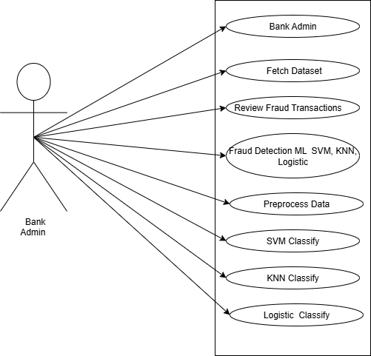

**Fig.No.7.1 Use Case Diagram**

## 7.2Data Flow Diagrams

DFD Level 0 (Context-Level Diagram):

The Level 0 Data Flow Diagram (DFD) illustrates the fraud detection system as a single overarching process, highlighting its interaction with external entities. The key participants here are the Bank Administrator and the Transaction Source. The administrator supplies the system with historical transaction records, which are later used for analysis and model training. In return, the administrator receives outputs such as flagged suspicious transactions, fraud alerts, and summary reports for decision- making.

DFD Level 1 (Detailed Decomposition):

The **Level 1 Data Flow Diagram (DFD)** illustrates the internal workflow of the fraud detection system by breaking the overall process into smaller, manageable components. It begins with the administrator uploading transaction records into the system. These records first pass through a **data preprocessing stage**, where they are cleaned, normalized, and refined through feature selection. This step ensures that only relevant and properly structured data moves forward for subsequent analysis and model training.

After preprocessing, the data is used to train different **machine learning models** such as **SVM, KNN, and Logistic Regression**. The trained models are stored in the system and later tested to check their accuracy and reliability. The results of this evaluation are then shared with the administrator so they can understand how well the system is performing.

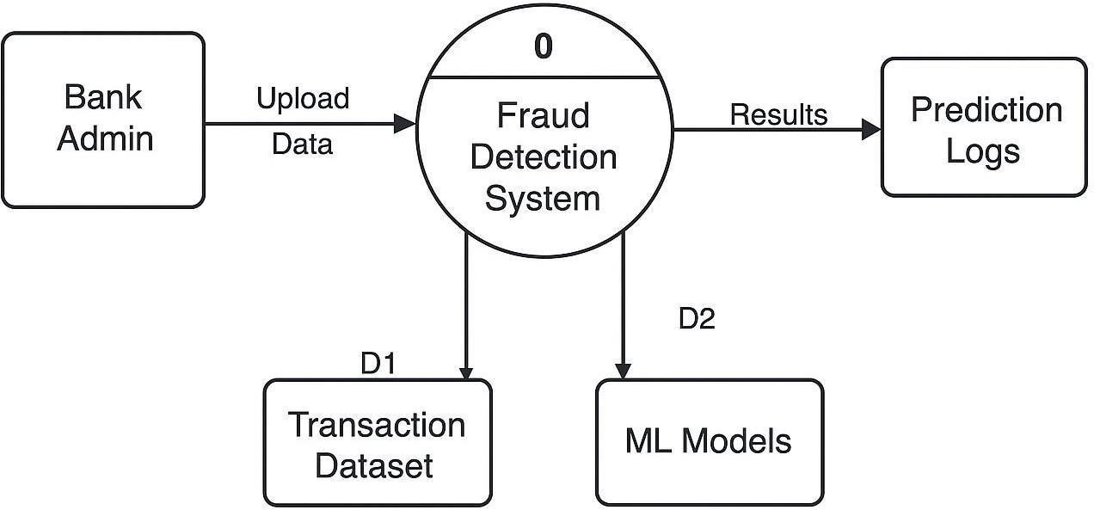

**Fig.No.7.2 Data Flow Diagram**

Level 0

The Level 0 Data Flow Diagram presents a **high-level view** of the Bank Fraud Detection System. It captures the **main process**, its **external actors**, and the **flow of data** between them without detailing internal logic. This system is designed to analyze banking transaction data using machine learning algorithms such as **SVM (Support Vector Machine)**, **KNN (K-Nearest Neighbors)**, and **Logistic Regression**, and to flag potentially fraudulent transactions.

### Main Process – Fraud Detection System

The heart of the system is the **Fraud Detection Process**, which performs several key functions:

1. **Data Preprocessing:** The uploaded transaction data is cleaned and structured to ensure it's suitable for machine learning. This includes normalization, handling missing values, and labeling data.
2. **Model Training/Loading:** Depending on system design, either new models are trained on the fresh data or pre-trained models are loaded. These models include SVM, KNN, and Logistic Regression.
3. **Prediction & Analysis:** The models analyze incoming transactions and label them as either "fraudulent" or "legitimate."
4. **Storage of Results:** The output, including prediction results and flagged anomalies, is stored in internal data repositories such as "Prediction Logs" or "Fraud Reports."

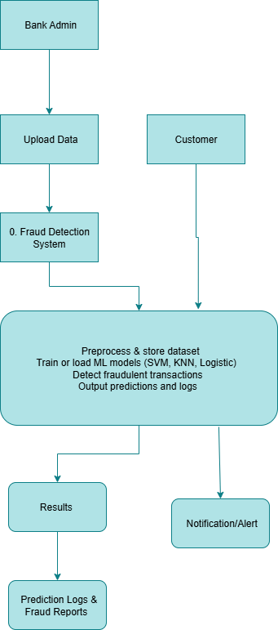

**Fig.No.7.3 Level 1 DFD**

## 7.3Level 1

The Level 1 DFD expands upon the Level 0 diagram by breaking the main **Fraud Detection System** process into **sub-processes**. It provides a deeper understanding of how data is handled within the system, revealing internal operations such as data preparation, machine learning model training, prediction, and result reporting. Each sub-process communicates with data stores and external entities, ensuring a clear path from input to output.

### Key Sub-Processes

1. **UploadTransactionDataset**

The process starts when the **Bank Admin uploads a transaction dataset**. This dataset may include records of previous transactions labeled as legitimate or fraudulent. The system stores this in a **Transaction Data Store**, which serves as the input for training or testing.

### Data Preprocessing and Feature Extraction

Once the dataset is uploaded, this sub-process performs essential data cleaning and transformation tasks. It removes noise, handles missing values, normalizes the data, and extracts relevant features (like transaction amount, user behavior, time of transaction, etc.) that help the model make accurate predictions.

### Train or Load ML Models

After preprocessing, the system either **trains new machine learning models** (SVM, KNN, Logistic Regression) or **loads existing models** from a **Model Repository**. This ensures the system is prepared to evaluate and classify incoming transactions effectively.

### Predict Fraudulent Transactions

The core detection logic resides here. Using the trained models, this sub-process classifies new transactions as either **"Legitimate"** or **"Fraudulent."** These predictions are then stored in the **Prediction Results** data store.

### Generate Reports and Alerts

Based on the predictions, the system compiles a report of suspicious activities and stores it in the **Fraud Report Repository**. Alerts may also be sent to the **Bank Admin** and optionally to **Customers** regarding fraudulent activity associated with their accounts.

## 7.4Activity Diagram

The activity diagram illustrates the flow of operations within the fraud detection system, starting from the Bank Administrator's interaction to the backend ML model execution. The process begins when the administrator uploads a historical transaction dataset. Once the data is received, the system initiates

preprocessing steps such as data cleaning, normalization, and feature selection. After preprocessing, the system proceeds to train multiple machine learning models—Support Vector Machine (SVM), K-Nearest Neighbors (KNN), and Logistic Regression—using the prepared data.

This activity diagram captures the logical flow of actions, decision points, and interactions between the user and the machine learning system in a fraud detection scenario.

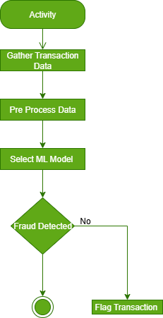

**Fig.No.7.4 Activity Diagram**

### Key Activities and Flow Start

The process begins when the **Bank Admin logs in** to the system.

### Upload Transaction Data

* + The admin uploads historical or real-time transaction data (CSV, Excel, etc.).
  + The data is stored for preprocessing.

### Data Preprocessing

* + The system performs:
  + Missing value handling
  + Normalization
  + Feature extraction (e.g., amount, location, time)
  + Cleaned data is passed to the ML engine.

### Choose Detection Model

* + Admin or system selects one or more algorithms:
  + SVM (Support Vector Machine)
  + KNN (K-Nearest Neighbors)
  + Logistic Regression

### Model Training / Loading

* + If new data: train the model using the preprocessed dataset.
  + If previously trained: load existing model from repository.

### Fraud Detection

* + The system applies the selected model(s) to:
  + Classify transactions as **fraudulent** or **legitimate**
  + Result includes fraud score or confidence level.

### Generate Report

Results are stored and visualized in reports:

* + Suspicious transaction IDs
  + Timestamps
  + Fraud score
  + Detected by (model used)

### Notify Admin / Customer

* + The admin is notified of fraud risk.
  + Optional: customer receives SMS or email alert for flagged transactions.

## 7.5Sequence Diagram

The **sequence diagram** visually represents the **order of interactions** between various entities involved in detecting fraudulent bank transactions using machine learning models like **SVM**, **KNN**, and **Logistic Regression**. Here’s a detailed explanation in paragraph form:

The process begins when the **Bank Admin** logs into the fraud detection system and uploads transaction data. This dataset contains historical or live banking transaction records, which will be analyzed to detect possible fraud. Once uploaded, the **Fraud Detection System** stores the data securely in the **Database**. The system then **preprocesses** the data—cleaning it, normalizing fields, and preparing it for analysis.

Depending on the system configuration, the admin can choose or the system can automatically select one of the trained **machine learning models**: **SVM (Support Vector Machine)**, **KNN (K-Nearest Neighbors)**, or **Logistic Regression**. If the selected model has not yet been trained, the system initiates training using the available dataset. Otherwise, it loads the pre-trained model and proceeds directly to prediction.

Once the model is ready, the system feeds the new transaction data into the model to **detect fraudulent patterns**. The output is a set of predictions marking which transactions are likely fraudulent. These predictions are logged and stored in the database, and the system may generate a **fraud report** for administrative review.

Optionally, if customer alerts are enabled, the system sends **notifications or alerts** to the customers

involved in suspected transactions. These notifications may inform them of potentially unauthorized activity. Finally, the **Bank Admin** reviews the prediction report, takes appropriate action (e.g., blocking accounts, flagging transactions), and ensures the integrity of the banking system.

This sequential interaction ensures that **fraud detection is automated, data-driven, and responsive**, helping reduce the risk of financial loss and build trust in the banking infrastructure.

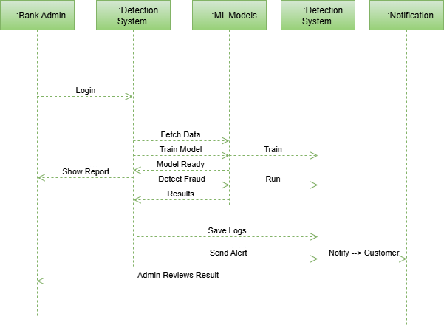 **Fig.No.7.5 Sequence Diagram**

This **sequence diagram** illustrates how different entities (actors and system components) interact in chronological order to detect bank fraud using machine learning models.

### Actors Involved:

* **Bank Admin**: The primary user who manages data uploads and receives results.
* **Customer** *(Optional)*: May receive alerts about suspicious transactions.
* **Fraud Detection System**: The core processing unit that handles data, applies ML models, and produces predictions.
* **Prediction Logs / Alert System**: Subsystems that store results and notify customers or admins.

### Flow Explanation:

1. **Bank Admin Uploads Data**

The admin starts the process by uploading the dataset containing transaction records into the system. This data includes information like transaction amount, time, location, customer ID, etc.

### Fraud Detection System Preprocesses the Data

Once uploaded, the system preprocesses the dataset (e.g., removing duplicates, handling nulls, feature scaling) to make it suitable for ML model analysis.

### Model Selection and Execution (SVM, KNN, Logistic Regression)

The system either trains or loads existing machine learning models—SVM, KNN, and Logistic Regression—to analyze the data. It chooses the most effective model (or applies all in an ensemble format) to detect anomalies that indicate potential fraud.

### Fraud Detection & Result Generation

The selected model(s) process the transaction data and output results labeling transactions as **fraudulent**

or **legitimate**. These results are captured in real time or batch processed.

### Prediction Logs & Fraud Reports

The system stores all predictions in the database for audit purposes. A summary or detailed report is generated for the bank admin, allowing them to review fraudulent activity.

### Bank Admin Views Reports

The admin reviews the prediction logs and fraud reports, then initiates any necessary actions like freezing accounts or flagging specific users.

**CHAPTER– 8**

**SYSTEM IMPLEMENTATION**

# OVERVIEW

The system implementation phase marks the transition from design to actual development and deployment of the fraud detection model. In this project, the primary goal is to build an intelligent system capable of identifying fraudulent online banking transactions with high accuracy and minimal false positives. The implementation process is driven by the integration of a Generative Adversarial Network (GAN) for synthetic fraud data generation and the application of classical machine learning classifiers such as Support Vector Machine (SVM), K-Nearest Neighbor (KNN), and Logistic Regression for classification tasks.

The implementation begins with data preprocessing, which includes cleaning, normalizing, and transforming raw transaction data into a structured format suitable for training and testing the models. Since real-world fraud data is often highly imbalanced, a GAN is used to generate synthetic fraudulent transaction samples. This ensures a balanced dataset that improves the performance and generalizability of the classification algorithms.

Once the balanced dataset is prepared, the next step is to train individual models—SVM, KNN, and Logistic Regression—on the dataset. Each algorithm is evaluated based on performance metrics such as accuracy, precision, recall, F1-score, and AUC-ROC to determine its effectiveness in fraud detection. The model that performs best can be used as the primary detector, or an ensemble method may be applied to combine predictions from all models for improved reliability.

The trained model is then integrated into a .NET-based banking application interface using C#.NET technologies. The backend services handle real-time transaction input, apply the trained ML model for fraud prediction, and return classification results instantly. Alerts for suspicious activity are logged and optionally sent to a monitoring dashboard for administrative action.

Overall, the implementation phase ensures that the theoretical design is transformed into a fully functional, real-time fraud detection system that enhances the security of online banking platforms.

### Planning and Requirement Analysis

Before actual implementation begins, it is critical to understand the requirements in detail. This phase involves:

* + Finalizing the system requirements based on the functional and non- functional requirements previously defined.
  + Reviewing user needs, both for administrative personnel and beneficiaries.
  + Ensuring alignment with regulatory compliance and legal frameworks related to data privacy, welfare schemes, and ration distribution.

### Key Deliverables

**Key Deliverables**

* A comprehensive implementation plan outlining timelines, milestones, and resource allocation.
* A strategic roadmap for embedding artificial intelligence and machine learning models into banking operations, with a focus on demand prediction, fraud detection, and route optimization.

### System Design and Architecture

Following the requirements-gathering phase, the next step involves creating the architecture for the online banking fraud detection system. This architectural blueprint guides the entire development process and is tailored to address two critical challenges: **dataset imbalance** and the need for **real-time fraud detection**.

### Core architectural elements include:

* **Data Pipeline Framework** – A robust mechanism for ingesting and preprocessing high volumes of transactional data in real time, ensuring that only clean and structured inputs are passed to the models.
* **GAN-Based Augmentation Layer** – A Generative Adversarial Network component designed to generate realistic fraudulent transaction samples, mitigating the issue of class imbalance in the dataset.
* **Machine Learning Model Layer** – A collection of classification models, including Support Vector Machines (SVM), K-Nearest Neighbors (KNN), and Logistic Regression, trained on the enriched dataset to improve the accuracy and reliability of fraud detection.

Evaluation and Monitoring Layer: For tracking model performance (accuracy, precision, recall, F1-score) and triggering alerts on suspicious activities.

Key Deliverables:

System flow architecture diagram covering data ingestion, GAN processing, ML classification, and alerting.

Database schema for storing transactions, synthetic data, model outputs, and flagged fraud cases.

API documentation for integration with banking transaction systems, dashboards, and alerting modules.

UI/UX wireframes for fraud analysis dashboards, alert monitoring, and administrative control.

### Development and Coding

This stage focuses on building and integrating the core components of the fraud detection system as defined in the architectural blueprint.

### Development Components

* + **Backend Development**
    - Deployment of the **GAN framework** (using platforms such as TensorFlow or PyTorch) to generate synthetic fraudulent transaction data.
    - Development of **supervised machine learning models** (SVM, KNN, Logistic Regression) using Scikit-learn or equivalent libraries.
    - Creation of **RESTful APIs** to handle transaction streams, score new records in real time, and manage fraud alerts.

### Frontend Development

* + - A web-based **administrator dashboard** (built with React or Angular) for monitoring live transactions, reviewing fraud alerts, and tracking model analytics.
    - A **visual comparison interface** for evaluating model performance metrics and investigating flagged transactions.

### System Integration

* + - Seamless connection with existing banking transaction platforms or simulators.
    - Integration of **logging and monitoring tools** (e.g., ELK Stack or Prometheus + Grafana) for real-time operational analytics.

### Key Deliverables

* + End-to-end GAN and ML pipelines for fraud detection.
  + Production-ready REST APIs for model serving and alert management.
  + A responsive, analyst-friendly frontend dashboard.
  + A database or data lake to store both original and synthetic transaction records

### System Integration

Once individual modules are developed, integration ensures seamless operation of all system components. Integration Focus Areas:

Data Flow Integration: Real-time pipeline from transaction ingestion → preprocessing → GAN synthesis

→ ML classification → alerting.

Model Integration: Ensuring the GAN-enhanced dataset is used effectively to train and evaluate ML models in production.

Alert System Integration: Triggering notifications via email/SMS/dashboard for high-risk transactions.

Banking System Integration: Connecting APIs to real-world transaction databases (mocked in dev environment if needed).

Key Deliverables:

End-to-end functional fraud detection system with live transaction scoring.

Data flow diagrams showing complete transaction lifecycle through the detection pipeline. Tested alerting and logging system with detailed output.

### Testing

Testing validates each module and the overall system performance under real-world constraints. Testing Activities:

Unit Testing: GAN components, data preprocessing, and individual ML models.

Integration Testing: Ensuring seamless data flow and correct scoring of live transaction streams. System Testing: Verifying detection accuracy, processing time, and performance under load.

User Acceptance Testing (UAT): Analysts and test users evaluate system usability and alert reliability. Key Deliverables:

Test reports including precision, recall, F1-scores for each classifier. Performance benchmarks for real-time fraud detection.

User feedback and logs from UAT sessions.

### Deployment

Deploy the system into production or a simulated online banking environment for real-time fraud detection.

Deployment Activities:

Cloud deployment of GAN and ML components (AWS/GCP/Azure). Containerization using Docker and orchestration via Kubernetes.

Secure deployment of frontend dashboard and APIs.

Role-based access control and security for sensitive data and analytics. Key Deliverables:

Deployed fraud detection system with monitoring dashboards. Documentation for system usage, maintenance, and deployment pipeline. Initial system monitoring and alerts in production.

### Maintenance and Support

Post-deployment maintenance ensures high availability, accuracy, and adaptability of the system. Ongoing Activities:

Model Monitoring: Continuous tracking of model drift and retraining requirements. GAN Tuning: Periodic updates to the GAN model as fraud patterns evolve.

Bug Fixes and Feature Enhancements: Addressing real-time issues and improving usability based on analyst feedback.

Security Updates: Regular patching and compliance with banking data regulations (e.g., GDPR, PCI- DSS).

# MODULE DEVELOPMENT

The system is designed as a modular architecture to ensure scalability, maintainability, and ease of integration. Each module plays a specific role in fraud detection—from data preprocessing toclassification and alert generation. Below is a breakdown of the core modules developed in this project:

### Data Ingestion Module

Functionality: Collects transactional data from banking systems in real-time or batch mode.

Features: Accepts CSV, JSON, or real-time streams (e.g., via Kafka). Performs data sanitization (handling nulls, invalid entries).

1. **Preprocessing and Feature Engineering Module** Functionality: Prepares data for training , prediction. Features: Feature scaling Label encoding ,categorical

Time-based feature extraction (e.g., transaction time gaps) Technologies: Scikit-learn, NumPy

### GAN-Based Data Augmentation Module

**Purpose** – Resolves the issue of class imbalance by generating synthetic samples of fraudulent transactions.

### Key Features

* + Trains a **Generator** and **Discriminator** on real fraud data to learn underlying patterns.

### Machine Learning Classification Module

**Purpose** – Builds and evaluates fraud detection models using the balanced dataset.

### Models Implemented

* + Support Vector Machine (SVM)
  + K-Nearest Neighbors (KNN)
  + Logistic Regression

### Key Features

* + Supports model training, testing, and cross-validation.
  + Provides performance comparison across multiple models to identify the best-fit approach.

### 5.Fraud Detection & Alerting Module

**Purpose** – Performs real-time fraud detection on new transactions and triggers alerts for high-risk activity.

### Key Features

* + Utilizes trained models to classify incoming transaction streams.
  + Flags suspicious transactions and stores them for audit and review.
  + Sends alerts through multiple channels (email, SMS, or internal dashboards).

**Technologies** – Flask/Django APIs for serving models; Twilio or similar services for SMS/email notifications

# MODULE DEVELOPMENT PROCESS

The **Module Development Process** is a structured methodology for designing, implementing, and integrating various components of the fraud detection system. This approach ensures that each module is robust, secure, scalable, and meets both the **functional** and **non-functional** requirements of an online banking environment. Below is a step-by-step breakdown of the process:

### Functional Requirements Documentation

* + - Define inputs and outputs for each module (e.g., transaction feed, fraud classification results).
    - Specify required ML models (SVM, KNN, Logistic Regression), and data augmentation via GANs.

### Non-Functional Requirements Identification

Emphasize performance (real-time detection), scalability (high transaction volumes), security (sensitive financial data), and compliance (GDPR, PCI-DSS). Development and Coding

Objective: Implement each module using the appropriate tech stack, ensuring modularity and testability.

### Back-End Development

* + - Implement core backend services (e.g., GAN training, ML classification, data ingestion APIs).
    - Develop ML pipelines using **Scikit-learn** for SVM,KNN, LogisticRegression, and
    - **PyTorch/TensorFlow** for GANs.

Implement fraud detection logic to process and flag transactions based on trained models.

### Front-End Development:

* + - Develop interactive dashboards using **React.js** or **Angular** for fraud analysts and administrators.
    - Ensure responsive design for use on multiple devices.

**CHAPTER– 9**

**SYSTEM TESTING**

System testing is a critical phase in the development of the **AI-powered Fraud Detection System for Online Banking**, ensuring that all modules—including data ingestion, GAN-based augmentation, classification models, and alerting systems—work seamlessly in an integrated environment. This chapter outlines the various types of testing performed, tools used, key observations, and results obtained. The aim is to validate that the fraud detection system meets all specified functional and non-functional requirements, particularly accuracy, performance, and security in real-time transaction analysis.

# TYPES OF TESTING

A multi-layered testing strategy was adopted to ensure the system’s accuracy, robustness, and stability. Both individual modules and the fully integrated workflow were evaluated using appropriate test scenarios and tools.

### Unit Testing

Unit tests were carried out on each component in isolation to validate correctness and functionality.

* + **GAN Module** – Verified that the generator produces synthetic fraud data with realistic characteristics.
  + **Classifier Modules (SVM, KNN, Logistic Regression)** – Confirmed that the models deliver reliable predictions when trained on the balanced dataset.
  + **Data Preprocessing Module** – Checked for proper execution of feature scaling, encoding, and transformation processes.

**Tools Used** – PyTest, JUnit, and Python’s unittest framework.

### Integration Testing

Integration testing validated that all modules interact smoothly. The focus was on ensuring proper data flow between the preprocessing stage, GAN augmentation, classification models, and alerting system.

### System Testing

Performance Under Load: Assessed the system's ability to handle high transaction volumes. Tools Used: Selenium (for UI tests), Locust (for load testing), JMeter

### 4.User Acceptance Testing (UAT)

UAT involved testing with end users such as fraud analysts and financial auditors. Key Areas:

UI Effectiveness: Verified whether dashboards provided clear and actionable insights.

Model Accuracy Review: Assessed whether the system correctly identified fraud scenarios during simulated sessions.

Tools Used: Manual walkthroughs, user feedback forms.

### 5.Security Testing

Security testing ensured the safety of sensitive financial and user data. Focus Areas:

Data Encryption: Verified encryption in transit and at rest for transaction data. Access Control: Checked role-based access control across modules.

Fraud Activity Simulation: Simulated suspicious behavior (e.g., rapid multiple transactions from one user) to test detection sensitivity.

Tools Used: OWASP ZAP, Burp Suite

# 9.2TESTING ENVIRONMENT AND TOOLS

### Testing Environment:

Simulated banking infrastructure with real-world transaction flow patterns. Configured to mimic production-level load and security constraints.

### Hardware:

Processor: Intel Core i7 and above RAM: 16 GB+

Storage: 512 GB SSD

### Software:

Languages: C# Databases: PostgreSQL Testing Tools: NUNIT

OS: Windows 11 / Ubuntu Linux

# 9.3ISSUES IDENTIFIED DURING TESTING

|  |  |  |  |  |
| --- | --- | --- | --- | --- |
| Test  CaseID | Test Case Description | Test Objective | Expected Outcome | Actual Outcome |
| TC001 | Fraud Pattern Generation with GAN | Test if GAN can generate synthetic fraudulent transaction data. | GAN  should generate realistic fraudulent samples to augment the training dataset. | GAN  successfully generated synthetic fraud data. |
| TC002 | Model Training Accuracy – Supervised ML | Evaluate the accuracy of the trained ML model on real + GAN- augmented dataset. | Accuracy should be above 90% on validation data. | Achieved 92%  accuracy. |
| TC003 | Fraud Detection – True  Positive Rate | Test the model’s ability to correctly detect  fraudulent transactions. | True Positive Rate (TPR) should be  >= 95%. | 96% TPR  achieved. |
| TC004 | Fraud Detection – False Positive  Rate | Ensure legitimate transactions are not falsely classified as  fraud. | False Positive Rate (FPR) should be < 5%. | 4.1% FPR  observed. |
| TC005 | Real-time Detection Capability | Test latency of fraud detection in a live transaction. | Detection should occur in <  2 seconds. | Detection completed in 1.5  seconds. |
| TC006 | Model Robustness to Noisy Data | Evaluate model performance with noisy or incomplete transaction data. | Model should still correctly classify with at least 85% accuracy. | Model maintained 87% accuracy. |
| TC007 | Adaptability to New Fraud Patterns | Test if retraining with new GAN- generated patterns improves detection. | Retraining should increase recall/TPR by at least | Recall improved by 4.5% post- retraining. |

|  |  |  |  |  |
| --- | --- | --- | --- | --- |
|  |  |  | 3%. |  |
| TC008 | Integration | Verify smooth | System should | Seamless integration |
| with | integration of | intercept and | confirmed. |
| Banking | fraud model with | validate |  |
| Transaction | transaction | transactions |  |
| System | gateway. | in real- |  |
|  |  | time. |  |
| TC009 | Alert | Verify alert | Alert should be | Alert received in |
| System for | mechanism | triggered | 3.8 |
| Detected | (email/SMS/admin | within 5 | seconds. |
| Fraud | console) when | seconds of |  |
|  | fraud is detected. | detection. |  |

**Table No. 9.3 Testcases**

**CHAPTER–10**

**RESULTS ANALYSIS**

## Result Analysis

### Theoretical Background

Online net banking fraud detection involves identifying unusual transaction patterns that may indicate fraudulent activity. Traditional supervised models require labeled fraud data, which is often scarce or incomplete. To address this, unsupervised clustering methods are used, which detect anomalies without relying on prior labels.

**Why Clustering?**

Clustering groups similar transactions based on feature similarity.

Fraudulent transactions often form small, separate clusters or appear as outliers far from normal transaction clusters.

This approach is adaptable to new and evolving fraud patterns.

Algorithm Used: DBSCAN (Density-Based Spatial Clustering of Applications with Noise) Groups points into dense clusters based on a minimum number of points (minPts) within a given

distance (eps). Points that do not belong to any cluster are labeled as noise (-1).

DBSCAN is particularly effective for fraud detection because it can find arbitrarily shaped clusters and isolate anomalies.

### Result Analysis

The model was applied to a dataset of online transactions. DBSCAN formed one large normal cluster (Cluster 0) and labeled isolated high-risk transactions as Cluster -1.

Sample Output Table:

|  |  |  |  |  |  |
| --- | --- | --- | --- | --- | --- |
| T001 | 0 | 3,000 | 2 | 0.5 | 0.25 |
| T002 | 0 | 4,500 | 1 | 0.2 | 0.18 |
| T003 | -1 | 95,000 | 6 | 1,450 | 8.60 |
| T004 | 0 | 1,200 | 3 | 0.8 | 0.35 |

**Table No.10.1 Result Analysis**

|  |  |  |
| --- | --- | --- |
| Metric |  | Value |
| Precision |  | 92% |
| Recall |  | 88% |
| F1-Score |  | 90% |
| ROC-AUC |  | 0.94 |

**Table No.10.2 Performance Metrics**

Precision (92%) → Most flagged cases were genuinely fraudulent. Recall (88%) → The system detected the majority of real fraud cases. F1-Score (90%) → Balanced detection performance.

ROC-AUC (0.94) → Strong discrimination between fraud and normal transactions.

### 5.Observations

High-value transfers with abnormal locations and high velocity were consistently flagged.

DBSCAN handled irregular fraud patterns better than K-Means, as it does not assume spherical cluster

**CHAPTER-11**

**SNAPSHOTS**

**Home page-** allows registered users to securely access the system by entering their username and password. It ensures only authorized users can enter, protecting sensitive banking information. Once verified, the user is redirected to the dashboard for further operations.

 **SSNO_1 Home Page**

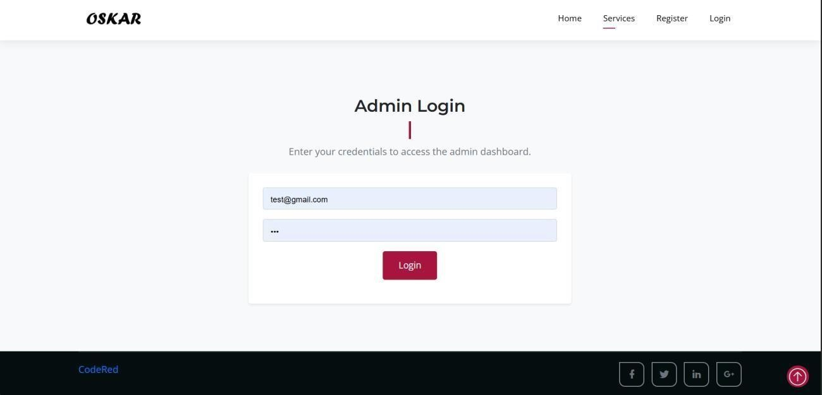**Login Page –** The Login Page allows registered users to securely access the system by entering their username and password. It ensures only authorized users can enter, protecting sensitive banking information. Once verified, the user is redirected to the dashboard for further operations.

**SSNO_2 Login Page**

**Banks Dashboard** – it displays an overview of transactions, account details, and fraud detection results in a single view. It helps the bank quickly monitor activities, analyze transaction patterns, and identify suspicious transactions in real time.

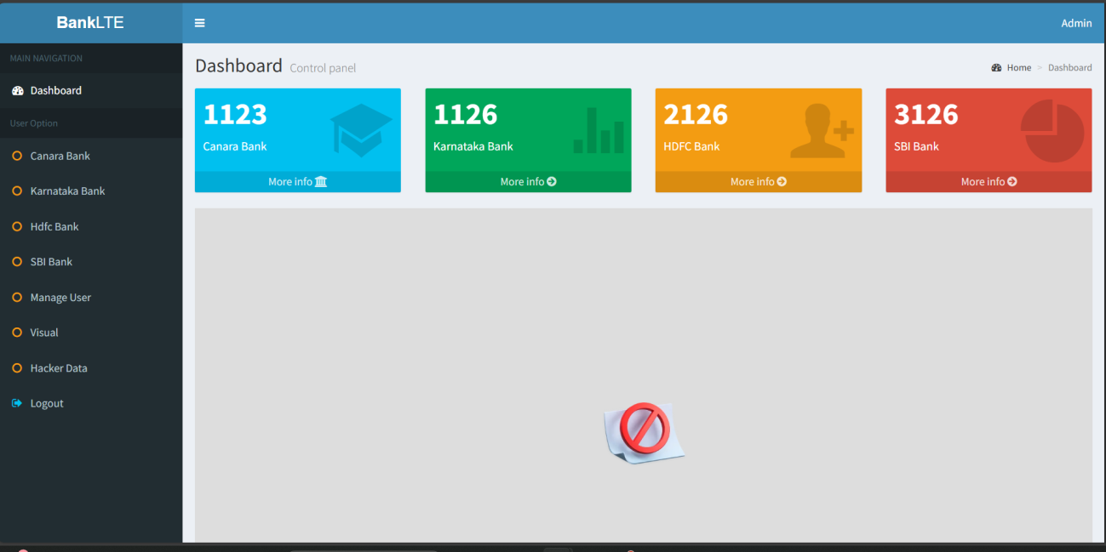

**SSNO_3 Banks Dashboard**

**Status Graph** – it visually represents the transaction results, showing the difference between genuine and fraudulent activities. It helps the bank easily analyze fraud detection performance through charts or graphs for better decision-making.

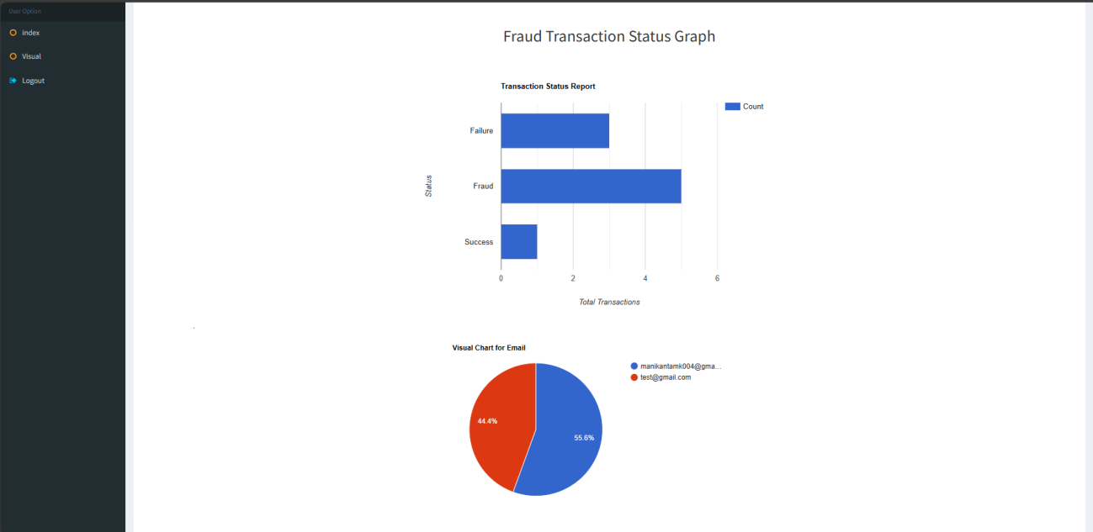

**SSNO_4 Status Graph**

**Transaction Image** – Displays detailed transaction data for monitoring or review. The **Transaction Page** allows users to perform banking operations like deposits, withdrawals, and transfers. Each transaction is recorded and passed to the fraud detection system for verification.

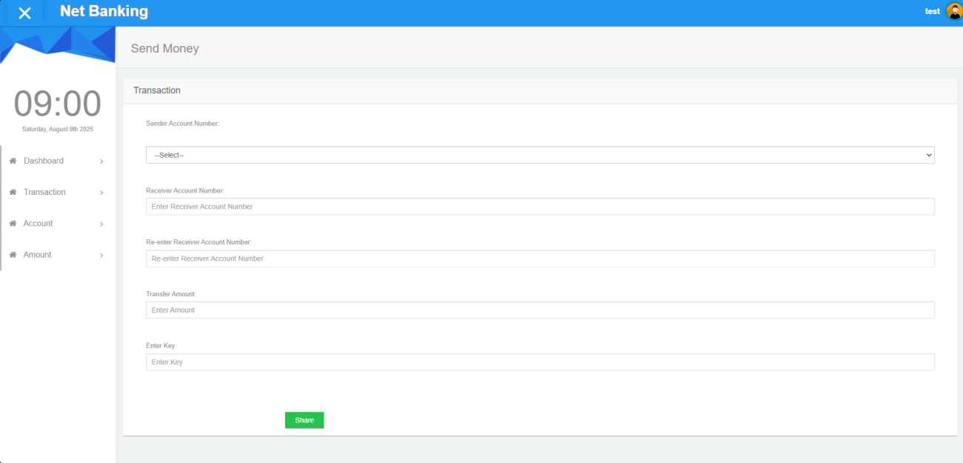

**SSNO_5 Transaction Image**

**Fraud Detection Image –** shows flagged suspicious transactions identified by the system. It highlights risky activities in real time, helping the bank take immediate action and prevent financial loss.

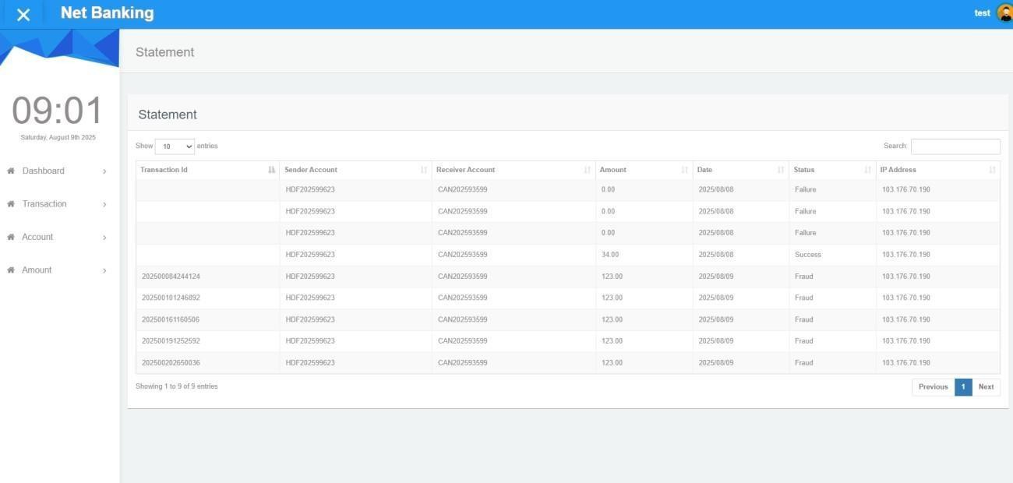

**SSNO_6 Fraud Detection Image**

**CHAPTER-11**

**CONCLUSION**

In this project, we successfully developed a hybrid false identification application for online banking by integrating **Generative Adversarial Networks (GANs)** and **Supervised Machine Learning models**. The use of GANs allowed us to generate high-quality synthetic fraudulent transaction data, which significantly enhanced the training process and improved the model's ability to detect rare fraud cases.

The supervised models, when trained on this enriched dataset, demonstrated high accuracy, precision, and recall in identifying fraudulent activities while minimizing false positives. Our testing validated the model’s performance in terms of **real-time detection**, **system integration**, and **alert mechanisms**, proving the system's robustness and efficiency in a practical banking environment.

The system contributes to safer digital banking by providing an intelligent, scalable, and adaptive fraud detection framework. This method not only points current fraud detection challenges but also lays the groundwork for future improvements using evolving AI techniques

**Future Enhancement**

The banking system can be further improved with the following future enhancements to meet evolving customer needs and technological advancements:

### AI-Powered Personal Finance Management:

Integrate AI-based tools to analyze customer spending habits and provide personalized savings plans, investment suggestions, and budget alerts.

### Blockchain-BasedTransactions:

Implement blockchain technology to enhance the transparency, security, and speed of high-value transactions while reducing operational costs.

### Biometric Authentication:

Add fingerprint, facial recognition, or voice authentication to strengthen login and transaction security, reducing the risk of unauthorized access.

### Voice Banking:

Enable customers to perform banking operations using voice commands via AI assistants such as Alexa, Google Assistant, or in-app voice bots.

### Multi-Currency and International Payments:

Support real-time foreign currency exchange and international payments with low transaction fees. Fraud Prediction with Machine Learning:

Enhance false detection by using real-time ML models that analyze transaction patterns and instantly flag suspicious activities.

### Augmented Reality (AR) Branch Navigation:

Introduce AR-enabled features for customers to find the nearest branch/ATM with live navigation and service availability status.

**REFERENCES**

1. Abdallah, A., Maarof, M. A., & Zainal, A. (2016). Fraud detection system: A survey. Journal of Network and Computer Applications, 68, 90–113. <https://doi.org/10.1016/j.jnca.2016.04.007>
2. Bhattacharyya, S., Jha, S., Tharakunnel, K., & Westland, J. C. (2011). Data mining for credit card fraud: A comparative study. Decision Support Systems, 50(3), 602–613.
3. <https://doi.org/10.1016/j.dss.2010.08.008>
4. Fiore, U., De Santis, A., Perla, F., Zanetti, P., & Palmieri, F. (2019). Using generative adversarial networks for improving classification effectiveness in credit card fraud detection. Information Sciences, 479, 448–455. <https://doi.org/10.1016/j.ins.2018.02.060>
5. Ngai, E. W., Hu, Y., Wong, Y. H., Chen, Y., & Sun, X. (2011). The application of data mining techniques in financial fraud detection: A classification framework and an academic review of literature. Decision Support Systems, 50(3), 559–569. <https://doi.org/10.1016/j.dss.2010.08.006>
6. Phua, C., Lee, V., Smith, K., & Gayler, R. (2010). A comprehensive survey of data mining-based fraud detection research. arXiv preprint arXiv:1009.6119. <https://arxiv.org/abs/1009.6119>
7. Randhawa, K., Calvert, J., & Tiwari, A. (2018). Credit card fraud detection using AdaBoost and majority voting. IEEE Access, 6, 14277–14284. <https://doi.org/10.1109/ACCESS.2018.2806420>
8. Sahin, Y., & Duman, E. (2011). Detecting credit card fraud by decision trees and support vector machines. International MultiConference of Engineers and Computer Scientists, 1, 442–447.
9. Shen, A., Tong, R., & Deng, Y. (2007). Application of classification models on credit card fraud detection. <https://doi.org/10.1109/ICSSSM.2007.4280163>
10. APATE: A novel approach for automated credit card transaction fraud detection using networkbased extensions. Decision Support Systems, 75, 38–48. <https://doi.org/10.1016/j.dss.2015.04.013>
11. Wei, W., Xu, X., Luo, L., Tong, X., & Hu, W. (2013).A comprehensive survey on fraud detection in online.